**QUIZ RESULTS**

**MODULE3: SUPPORT VECTOR MACHINES**

|  |  |  |  |  |
| --- | --- | --- | --- | --- |
| **No.** | **Quiz title** | **Completion Status** | **Score** | **Coursera link** |
| 1 | Module3_1_Support Vector Machines | Completed | 100% | [Quiz 1](https://www.coursera.org/learn/supervised-machine-learning-classification/assignment-submission/mImEv/support-vector-machines/view-feedback) |
| 2 | Module3_2_Support Vector Machines Kernels | Completed | 100% | [Quiz 2](https://www.coursera.org/learn/supervised-machine-learning-classification/assignment-submission/R6rBQ/support-vector-machines-kernels/view-feedback) |
| 3 | Module3_3_Support Vector Machines Labs | Completed | 100% | [Quiz 3](https://www.coursera.org/learn/supervised-machine-learning-classification/assignment-submission/GQruW/support-vector-machines-labs/view-feedback) |
| 4 | Module3_4_Support Vector Machines | Completed | 100% | [Quiz 4](https://www.coursera.org/learn/supervised-machine-learning-classification/assignment-submission/PAsR0/module-3-graded-quiz-support-vector-machines/view-feedback) |

# Module3_Support Vector Machines

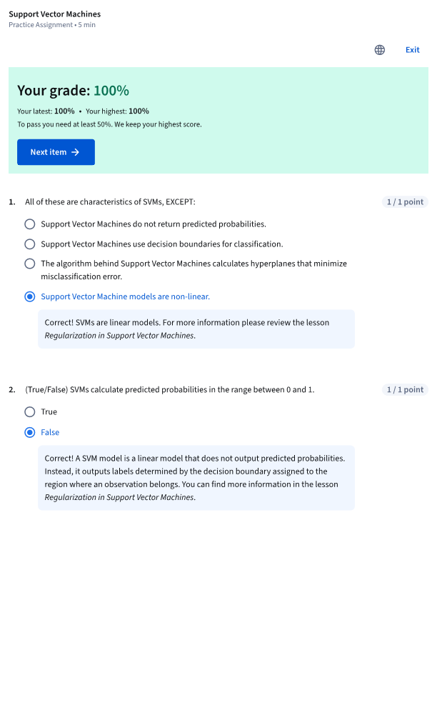

# Module3_Support Vector Machines Kernels

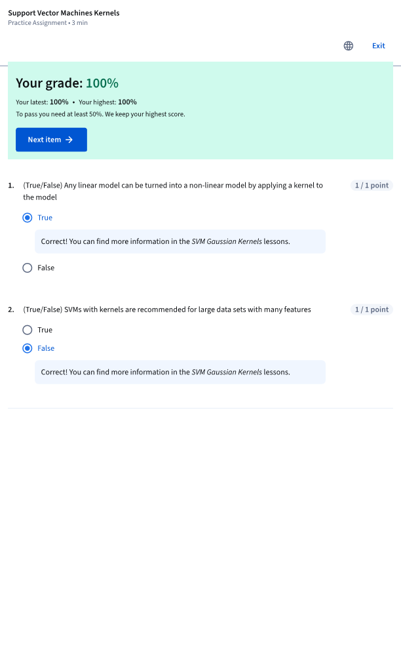

# Module3_Suport Vector Machines Labs

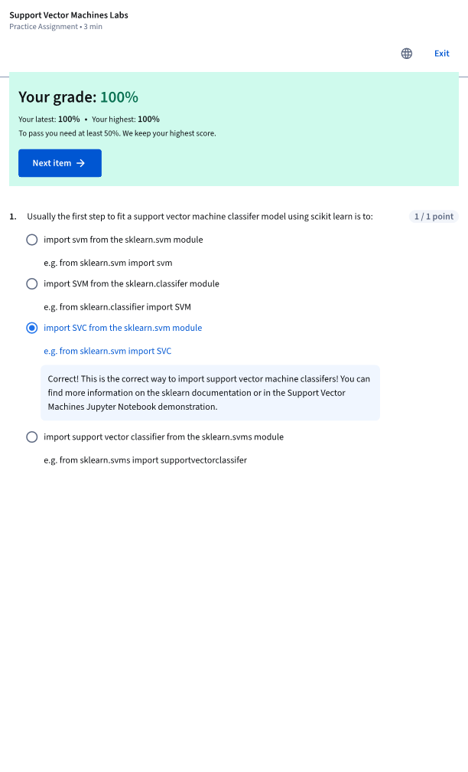

# Module3_Suport Vector Machines

